Week 4.2: Understanding Gel electrophoresis

## Part 1: Warm-up questions

1. What sort of information would you get when analysing a DNA gel electrophoresis after your PCR reaction? (Think about the principles of gel electrophoresis.)
2. Describe how you would optimise these parameters (gel concentrations and electrical voltage) to achieve the best resolution for separating DNA fragments of varying sizes.
3. In terms of your PCR reaction, could you describe the size of your product and give reasons for your choices?

## Part 2: Analysing gel electrophoresis data to check which patients have Huntington`s disease

Huntington's Disease and a few other diseases can be caused by something called Triplet Expansion. In the case of Huntington's disease, the nucleotide triplet, CAG occurs in the gene, and is repeated up to 28 times in a "Normal" individual. The severity and the onset of disease increase as the number of CAG repeats increases. For example, if a person has 36-40 CAG repeats, then there can be a weak phenotypic effect of the disease. Finally, anything over 40 repeats will have a strong phenotype and achieve a full phenotypic effect for the disease. Fortunately, scientists and doctors can diagnose the effects of the disease by measuring the size and the number of CAG repeats.

Using the model sequence below, you will design PCR primers that can be used to test a patient's DNA sample for the number of repeats in the gene and determine if the person is homozygous or heterozygous for the specific Huntington's allele(s).

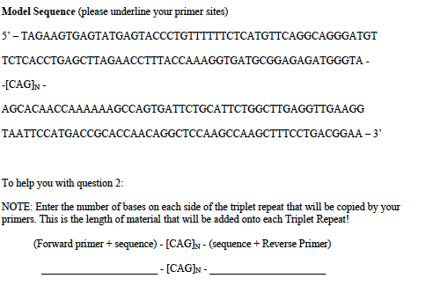

What are the steps required to get the forward and reverse primer sequence? Please write down your logic and thoughts. First, using the sequence given below, design PCR primers to generate a fragment of DNA. Fill in the table below to check out the predicted amplicon size.

Predicted amplicon size

| Number CAG repeat (N) | CAG Repeat Lenght | Length of ADDED PCR-generated DNA | Amplicon Product (PCR + Triplet) |
| --- | --- | --- | --- |
| 0 |  |  |  |
| 25 | 75nt |  |  |
| 30 |  |  |  |
| 40 |  |  |  |
| 60 |  |  |  |

The forward and reverse primers must be located on either side of the triplet expansion region shown as [CAG]N where the number of triples is noted by N.

Here is a figure showing the gel electrophoresis analysis of a number of patients that are suspected of having Huntington's disease.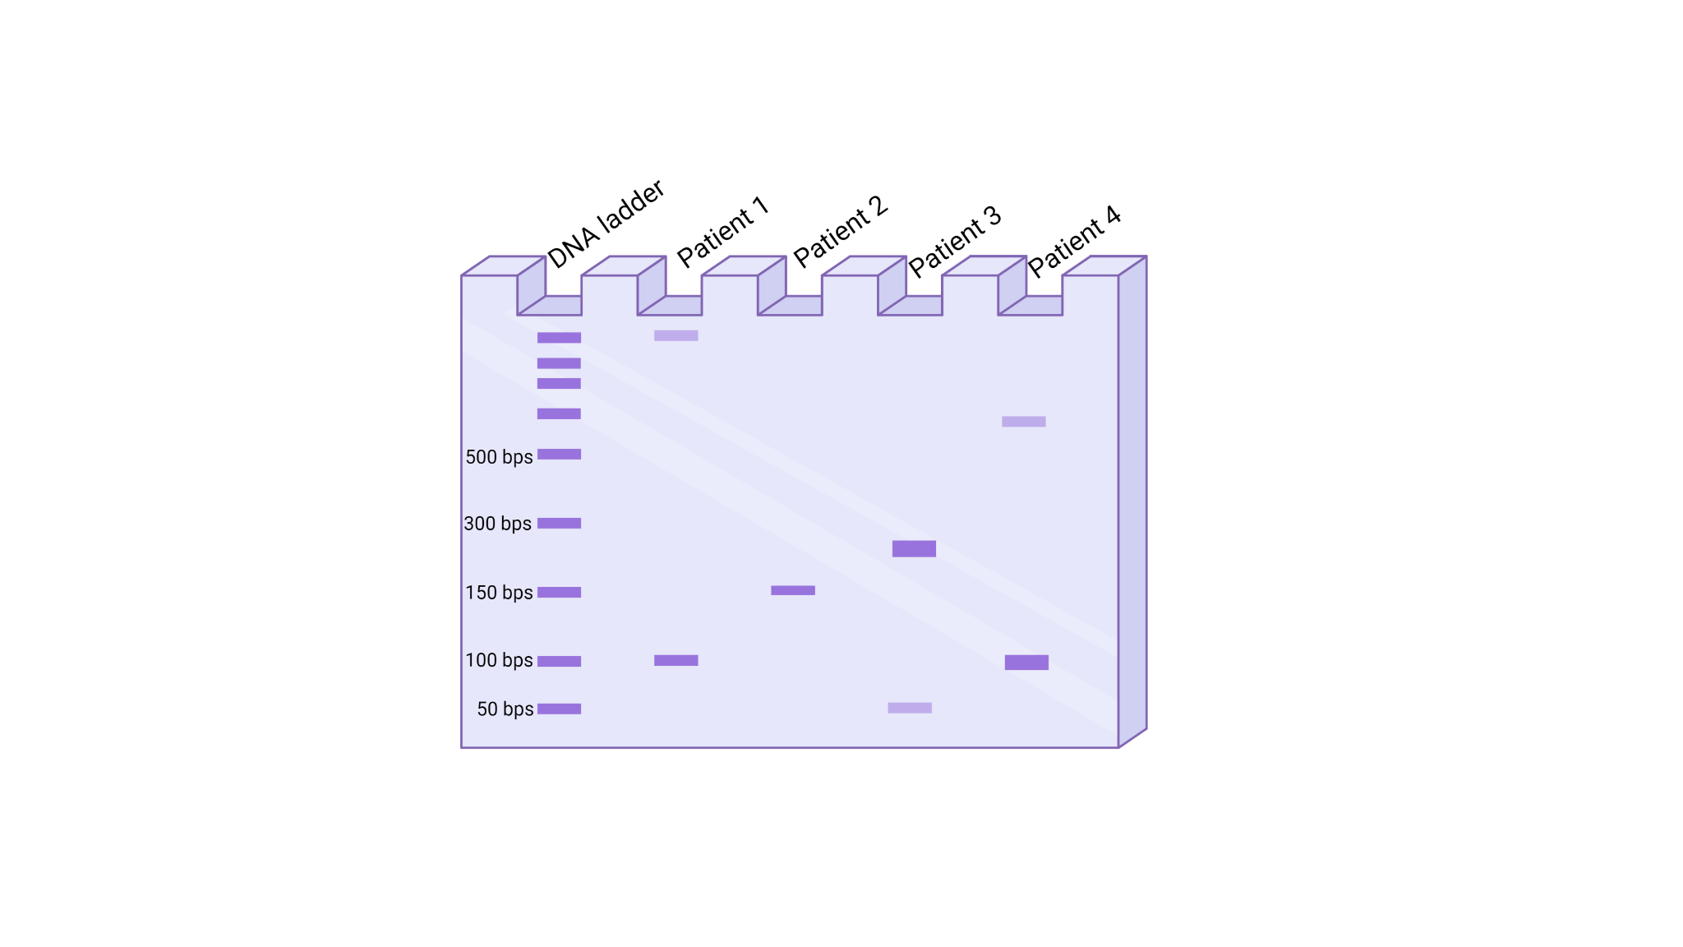

Based on the gel picture above, could you identify which individual has “no Huntington”, “mild Huntington” or “severe Hungtinton”

1. No disease:
2. Mild disease:
3. Severe disease: